Cognizant Academy teams want to maintain a list of trainers along with their expertise in a SPA using React as the technology. You are assigned the task of creating this React app.

**App.js:**

import { BrowserRouter, Routes, Route, Link } from "react-router-dom";

import Home from "./Home";

import TrainerList from "./TrainerList";

import TrainerDetails from "./TrainerDetails";

import trainersMock from "./TrainersMock";

function App() {

  return (

    <BrowserRouter>

      <div>

        <h1>My Academy Trainers App</h1>

        <nav>

          <Link to="/">Home</Link> | <Link to="/trainers">Show Trainers</Link>

        </nav>

        <Routes>

          <Route path="/" element={<Home />} />

          <Route path="/trainers" element={<TrainerList trainers={trainersMock} />} />

          <Route path="/trainers/:id" element={<TrainerDetails />} />

        </Routes>

      </div>

    </BrowserRouter>

  );

}

export default App;

**TrainerDetails.js:**

import { useParams } from "react-router-dom";

import trainersMock from "./TrainersMock";

function TrainerDetails() {

  const { id } = useParams();

  const trainer = trainersMock.find(t => t.trainerId === id);

  if (!trainer) return <p>Trainer not found</p>;

  return (

    <div>

      <h3>Trainers Details</h3>

      <h4>{trainer.name} ({trainer.technology})</h4>

      <p>{trainer.email}</p>

      <p>{trainer.phone}</p>

      <ul>

        {trainer.skills.map((skill, index) => (

          <li key={index}>{skill}</li>

        ))}

      </ul>

    </div>

  );

}

export default TrainerDetails;

**TrainerList.js:**

import { Link } from "react-router-dom";

function TrainerList({ trainers }) {

  return (

    <div>

      <h3>Trainers List</h3>

      <ul>

        {trainers.map(trainer => (

          <li key={trainer.trainerId}>

            <Link to={`/trainers/${trainer.trainerId}`}>{trainer.name}</Link>

          </li>

        ))}

      </ul>

    </div>

  );

}

export default TrainerList;

**Home.js:**

function Home() {

  return (

    <div>

      <h2>Welcome to My Academy trainers page</h2>

    </div>

  );

}

export default Home;

**TrainerMock.js:**

import Trainer from "./trainer";

const trainersMock = [

  new Trainer('t-syed8', 'Syed Khaleelullah', 'khaleelullah@cognizant.com', '97676516962', '.NET', ['C#', 'SQL Server', 'React', '.NET Core']),

  new Trainer('t-jojo', 'Jojo Jose', 'jojo@cognizant.com', '9897199231', 'Java', ['Java', 'JSP', 'Angular', 'Spring']),

  new Trainer('t-elisa', 'Elisa Jones', 'elisa@cognizant.com', '9871212235', 'Python', ['Python', 'Django', 'Angular']),

];

export default trainersMock;

**Trainer.js:**

class Trainer {

  constructor(trainerId, name, email, phone, technology, skills) {

    this.trainerId = trainerId;

    this.name = name;

    this.email = email;

    this.phone = phone;

    this.technology = technology;

    this.skills = skills;

  }

}

export default Trainer;

**OUTPUT 1:**

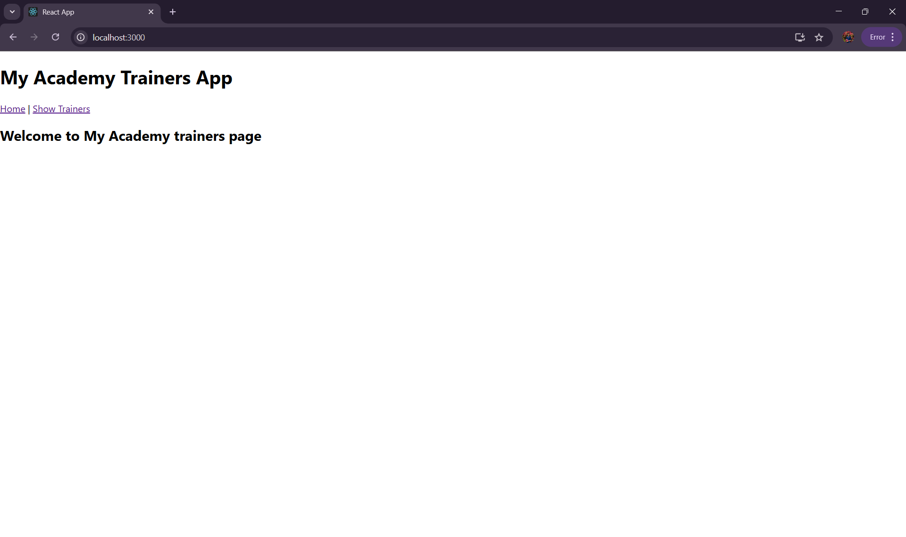

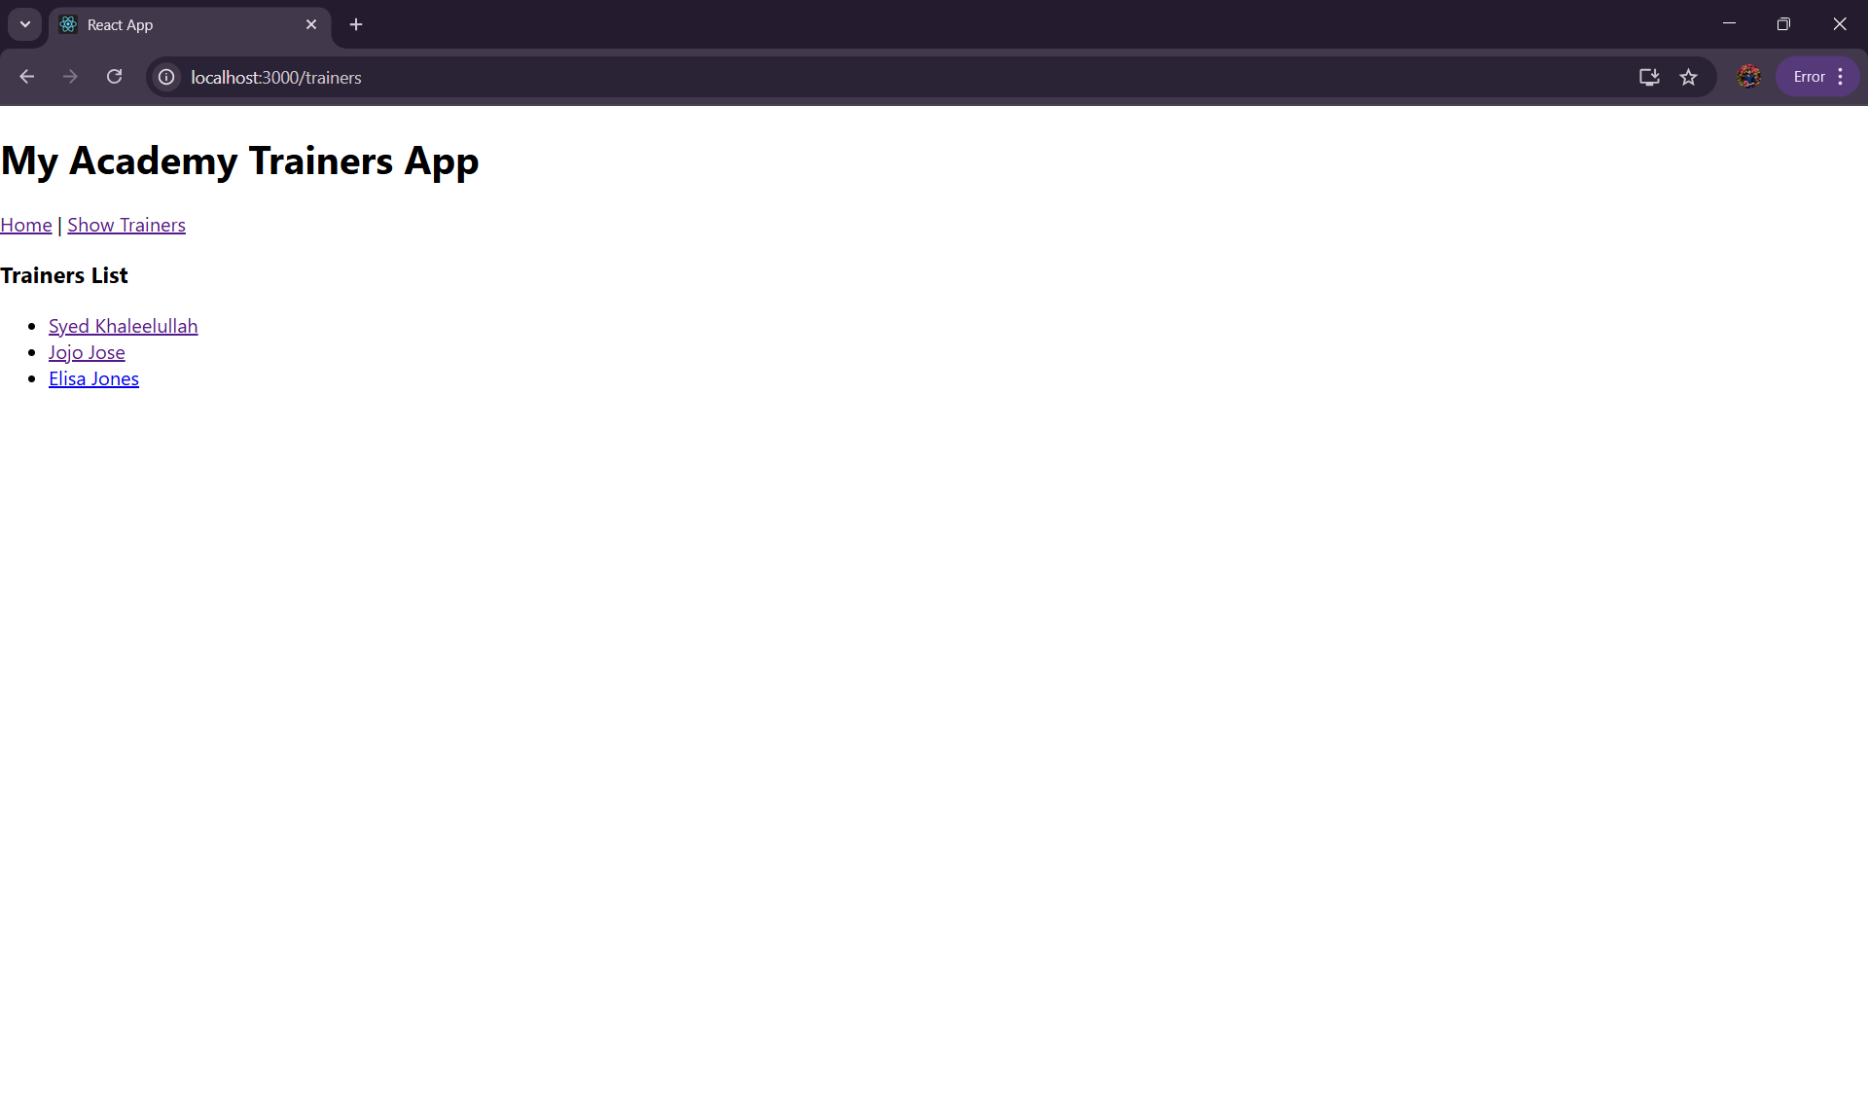**OUTPUT 2:**

**OUTPUT 3:**

